Sri Lanka Institute of Information

Technology



Lab Submission

Lab sheet No 10

**IT24101927**

**Liyanage J. L. K. L.**

**IT2120 - Probability and Statistics**

B.Sc. (Hons) in Information Technology

**Exercise**

1. A vending machine owner claims that customers choose the four snack types (A, B, C, D) with equal probability. To test this claim, a researcher records the number of purchases for each snack type during one week and results are given below.



1. State the null and alternative hypotheses for the test.

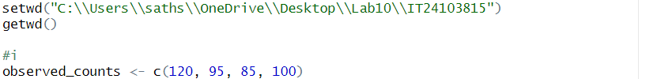

Answer:-

1. Perform a suitable chi-squared test to test the null hypothesis.

Answer:-



1. Give your conclusions based on the results. A black and white image of letters and numbers

   AI-generated content may be incorrect.

Answer:-

